**DAILY ONLINE ACTIVITIES SUMMARY**

|  |  |  |  |
| --- | --- | --- | --- |
| **Date:** | 22/05/2020 | **Name:** | Krishnitha |
| **Sem & Sec** | 4th sem, A Section | **USN:** | 4AL18CS039 |
| **Online Test Summary** | | | |
| **Subject** | Operating System | | |
| **Max. Marks** | 30 | **Score** | 22 |
| **Certification Course Summary** | | | |
| **Course** | Cyber Security Essentials | | |
| **Certificate Provider** | Cisco Network  Company | **Duration:** | 3 hrs. |
| **Coding Challenges** | | | |
| **Problem Statement:**  1) Write a C or Java program to implement round robin type of process scheduling.  2) Write a C Program to implement various operations on Singly Linked  List Stack | | | |
| **Status:** Executed | | | |
| **Uploaded the report in GitHub** | | YES | |
| **If yes Repository name** | | 1) <https://github.com/krishnitha/C-coding/blob/master/RoundRobin.c>  2) <https://github.com/krishnitha/C-coding/blob/master/SLL.c> | |
| **Uploaded the report in slack** | | YES | |

Online Test Details:

Today we had assessment in the subject Operating System. It was based on first module of this subject. There were total 30 number of questions of 1 mark each.

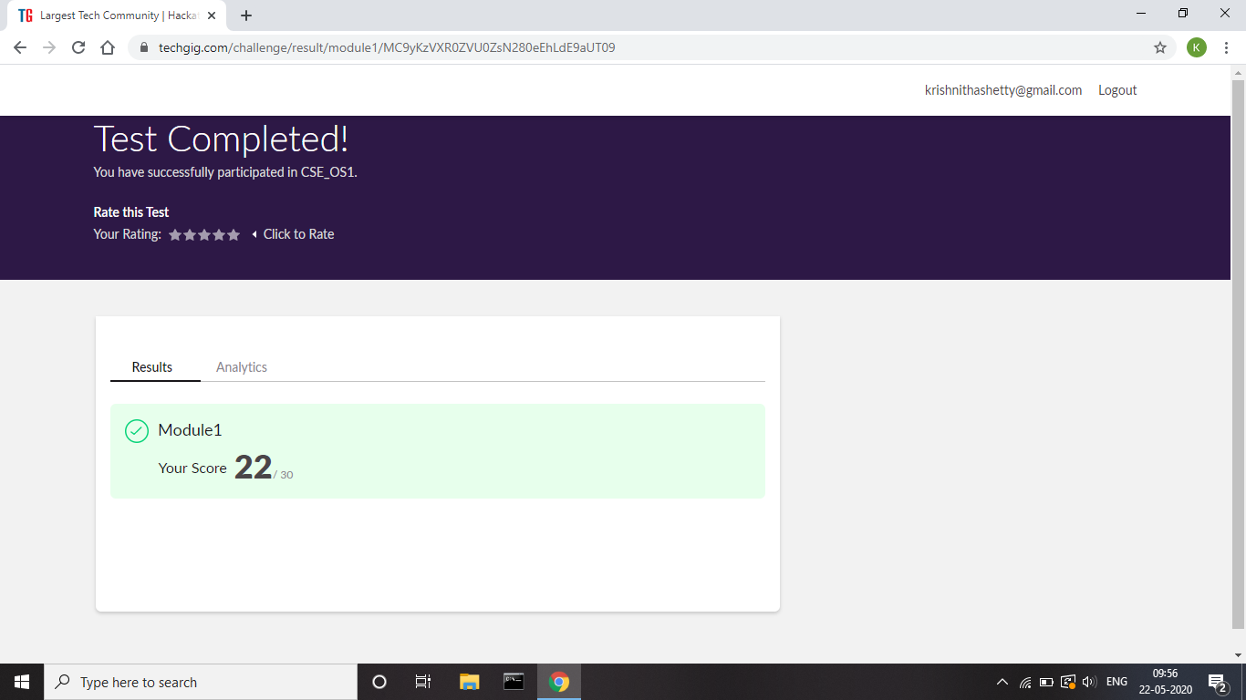

Certification Course Details:

Today I have done the course Cyber Security Essentials. It includes

following topics:

* The characteristics of criminals and heroes in the cybersecurity
* realm.
* The principles of confidentiality, integrity, and availability as they
* relate to data states and cybersecurity countermeasures.
* The tactics, techniques and procedures used by cyber criminals.
* How technologies, products, and procedures are used to protect
* confidentiality.
* How technologies, products, and procedures are used to ensure
* integrity.
* How technologies, products, and procedures provide high
* availability.
* How cybersecurity professionals use technologies, processes, and
* procedures to defend all components of the network.
* The purpose of laws related to cybersecurity.

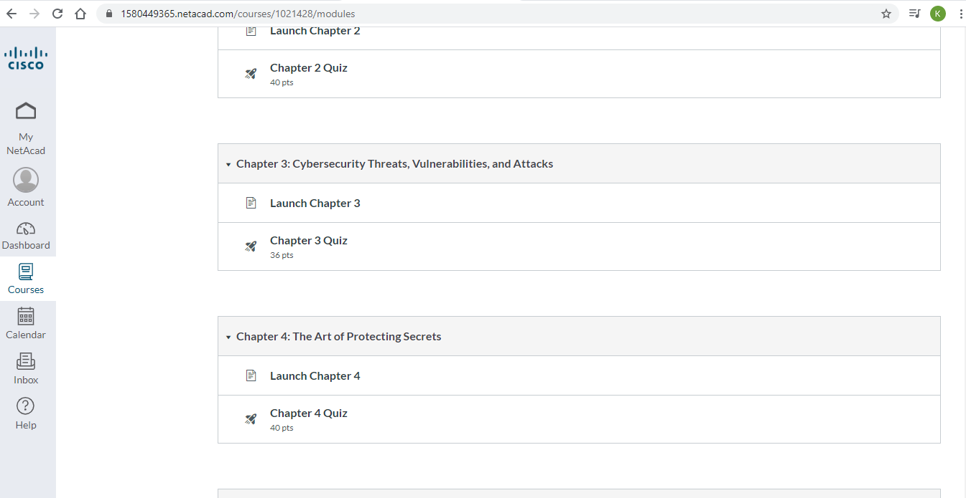

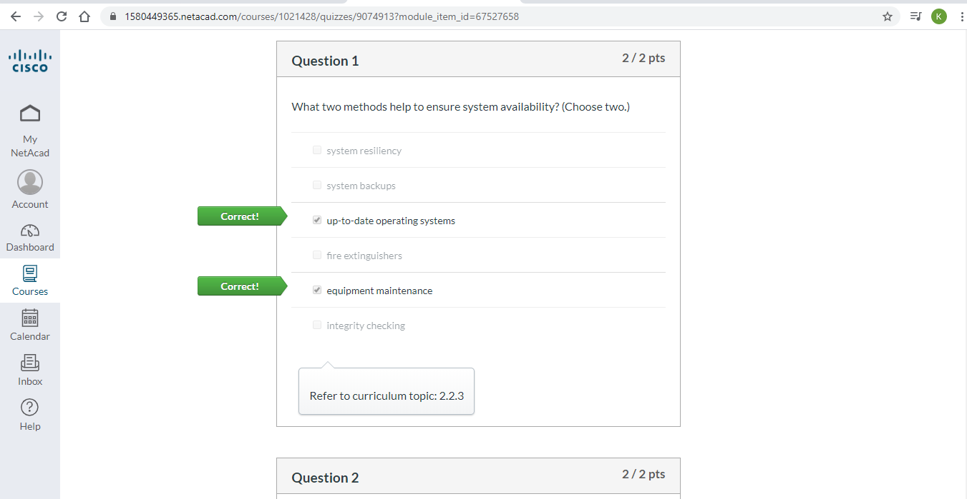

Coding Challenges Details:

Problem 1: Write a C or Java program to implement round robin type of process

scheduling.

**Input:** Process with burst time, arrival time and specify the time quantum.

**Output:** Processes scheduled based on the round robin type of scheduling, with its average waiting time.

**Solution:** Uploaded it in GitHub

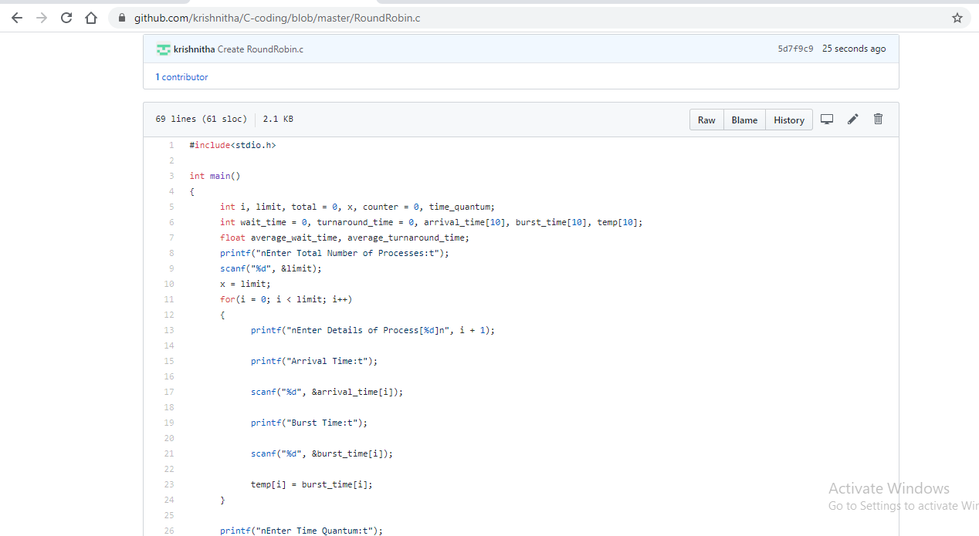

Problem 2: Write a C Program to implement various operations on Singly Linked List Stack

**Hint:** First Create a Singly Linked List Stack with the node corresponding to First Element is the base of the stack; and its link field must be always Null. When you push First Element, it is the First and it is Base of the stack. Its Link must be Null. top pointer pointing to First. (top = First) When you push any element, (No need of checking Stack full case because SLL is dynamic) Create a new node called temp using malloc function and insert the a number into Data field, and Link field must be pointing to top; and move the pointer top to point to temp. When you pop, First check for stack Empty. if First == NULL, then Stack Empty. If it is not empty, the pointer temp must be pointing to top. Move the pointer top to top-& gt;link. delete temp. When you display the stack element, First Check for Stack Empty as in pop operation. If it is not empty, display all the elements of current stack starting from top to First.

**Solution:** Uploaded it in GitHub

